**[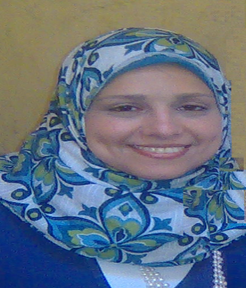](http://www.all-docs.net/wp-content/uploads/2012/02/headshot-icon.png)***c.v*

PERSONAL DETAILS

**Name** : Aml Abdelhafiz Elsayed **T. Number**  : +971503379673 **Email**  : [aehab26@gmail.com](mailto:aehab26@gmail.com) **Address** : UAE -Abu Dhabi **Languages** : Arabic and English **Religion** : Muslim **Nationality** : Egyptian **Marital Status** :  Married **Sex** : Female **Passport No.** : A00601133 **Issue Date:**  22th Feb 2009 **Expiry Date:** 21th Feb 2016

EDUCATION

* May 2004 – Diploma in Social Service Cairo University

OTHER SKILLS

* Data Entry
* Microsoft Office
* Surfing on the internet
* Reading
* Traveling

WORKING EXPERIENCE

* 2010 – Present – ***Executive Secretariat***Aml Center for Consulting and Development Abu Dhabi
* 2008 – 2010 – ***Social worker***Institute of Primary Azhary Cairo
* 2005 – 2008 – ***Secretariat*** *Publishing House* Cairo

TRAINING COURSES

* The preparation of the social specialist outstanding program
* Psychological footprint for children "temperamental child "
* Skills to deal with individual cases of student problems
* Identify problems and behavioral skills modified
* Creativity of student creativity parameter
* Personal patterns kids.